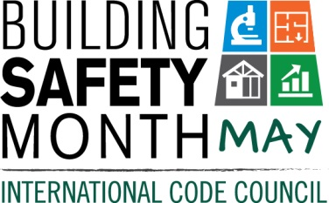
Sample Letter to the Editor
To help you promote Building Safety Month and the important role you play in your community, the International Code Council is providing you with this draft Letter to the Editor to promote your department with local newspapers, television and radio. Go to www.buildingsafetymonth.org, download the letter, fill in the appropriate information and send it in early April to your local newspaper’s editorial page editor. Some radio and TV news departments may have an editorial director. If not, send it to the news director. Be sure to list any special events you will be holding in conjunction with Building Safety Month.
Dear Editor:
America will celebrate Building Safety Month during May. The theme is Building Codes: Driving Growth through Innovation, Resilience and Safety. Each week of Building Safety Month spotlights a specific area of building safety: Building Solutions for All Ages, May 2-8; The Science Behind the Codes, May 9-5; Learn from the Past, Build for Tomorrow, May 16-22; and Building Codes: A Smart Investment, May 23-29.
The (name of jurisdiction and department) is a Building Safety Month supporter and participant. First observed in 1980, the goal of Building Safety Month is to raise public awareness of critical safety issues from structural to fire prevention, plumbing and mechanical systems, and energy efficiency. Building safety impacts everyone.
Last year, a Presidential proclamation declared Building Safety Month nationally and governors, mayors and other elected officials across America signed proclamations supporting the public safety effort. This year, the community is continuing to work together to ensure public safety. (Insert a reference to recently adopted codes, Building Safety Month plans, or other examples that illustrate the value of building safety in your community.)
Among the 57,000 members of the International Code Council that created Building Safety Month are code officials, plan reviewers, fire inspectors, architects, builders, engineers, contractors and others in the construction industry, including staffers in the (name of jurisdiction and department) who work to ensure the safety of the buildings where we live, work, learn, worship and play. Those officials provide the first line of defense against building disasters. We are silent but vigilant guardians who work daily to ensure safety in the built environment.
(Insert brief summaries of your building department accomplishments. Remind the community how it obtains permits and for what projects they are required.)
Local activities during Building Safety Month include (insert any activities you have planned including date, time and location). Educational materials are available for schools and the community at large including children’s activity books; and brochures about flood cleanup, mold prevention, green building and preparing for natural disasters. The public is encouraged to participate and learn about the essential safety work of the (name of jurisdiction and department). The (name of jurisdiction and department) is a member of the Code Council, whose members develops the most widely used building safety and fire prevention codes in the nation.
Your Name
Your Title
Your Office Phone Number

