2018 ICC Awards Call for Nominations-Educator of the Year
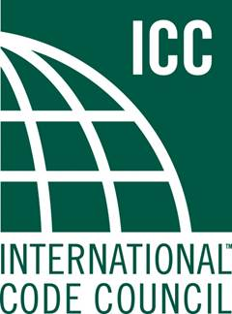

Nominations are now being accepted for the Educator of the Year Award.
The deadline to submit nominations for this year’s Educator of the Year Award is March 1st, 2018. Completed nomination forms must be received via email, US mail or fax by close of business Pacific Time Zone of the deadline date

EDUCATOR OF THE YEAR AWARD. This award is given to an individual or organization upon recommendation by the Education Committee for excellence in education and promoting professional development among ICC Members. This award is given in honor of Brent Snyder for his contributions to ICC Members to further their educational pursuits and professional development.

2018 ICC Educator of Year Call for Nominations (Application)

Name of Nominee:
Nominee Title:
Nominee eMail Address:
Nominee Telephone:
Nominee Jurisdiction/Organization/Company:

Please explain why this person or organization should be considered for the chosen award. Some of the areas that may be touched upon are as follows:

Innovation: use of new, creative or inventive teaching methods
Dedication: passion in the pursuit of educational excellence
Talent/Impact: effectiveness of instructional practices or educational contributions with an engaging and inspiring presence that motivates students and colleagues
Contribution: promotion and support of ICC and its Members through various means
Expertise: knowledge, understanding and experience with subject matter
Other: anything else you feel should be noted that would help the Education
Committee in evaluating the application

Brief description, biography, previous awards, recognitions, etc. of the nominee individual or organization
Feel free to include enclosures such as photos, DVDs, websites, YouTube videos, social media pages, etc.

Name of the individual or organization presenting the nomination:

If organization, include contact name:
Nominator Address:
Nominator Telephone:
Nominator eMail Address:

Email, mail or FAX the completed forms:
Email Casey Thomas: cthomas@iccsafe.org
Mail: Attn: Casey Thomas; ICC Western Regional Office; 3060 Saturn Street, Suite 100; Brea, CA 92821.
FAX: 562-908-5524
Questions may be emailed to cthomas@iccsafe.org or call 888-422-7233 x3389

