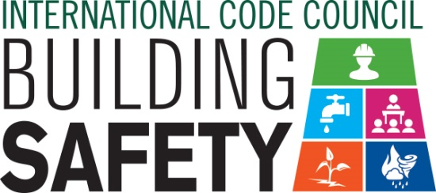
Sample Letter to the Editor
Dear Member: To help promote Building Safety Month and the important role you play in your community, the International Code Council is providing this draft letter to the editor to promote your department through local newspapers. Fill in the appropriate information and send it in early April to your newspaper’s editorial page editor. Be sure to list any special events you will be holding in conjunction with Building Safety Month.
Dear Editor:
America, along with many other countries, will celebrate Building Safety Month during May 2018 for the 38th year. This year building safety is especially important as we recover from devastating hurricanes and wildfires. Building codes save lives by incorporating the latest technology and providing the safest, most resilient structures for our families and communities. The International Codes, developed by the Code Council and adopted by our community, are the most widely used and adopted set of building safety codes in the U.S. and around the world.
First observed in 1980, Building Safety Month raises awareness of critical safety issues from structural to fire prevention, plumbing and mechanical systems, and energy efficiency. Each week of Building Safety Month spotlights a specific area of building safety, including Partnering with Code Officials to Build Stronger, Safer Communities, May 1–5; Advancing Resilient Communities through Science and Technology, May 6–12; Protecting Communities from Disasters, May 13–19; Safeguarding Our Water, May 20–26; and Improving Education and Training Standards for a Safer Tomorrow, May 27–31.
The (name of jurisdiction and department), a member of the Code Council, is a Building Safety Month supporter and participant. (Insert a reference to recently adopted codes, Building Safety Month plans, or other examples that illustrate the value of building safety in your community.)
Among the 64,000 members of the International Code Council that created Building Safety Month are code officials, plan reviewers, fire inspectors, architects, builders, engineers, design professionals, contractors and others in the construction industry, including staffers in the (name of jurisdiction and department) who work to ensure the safety of the buildings where we live, work and play. These officials provide the first line of defense against building disasters. We are silent but vigilant guardians who work daily to ensure the safety of our communities.
(Insert brief summaries of your building department accomplishments. Remind the community how it obtains permits and for what projects they are required.)
Local activities during Building Safety Month include (insert any activities you have planned including date, time and location). Educational materials are available for schools and the community at large including brochures about flood cleanup, mold prevention, green building and preparing for natural disasters. Everyone is encouraged to participate and learn about the essential safety work of the (name of jurisdiction and department).
Your Name
Your Title
Your Office Phone Number

