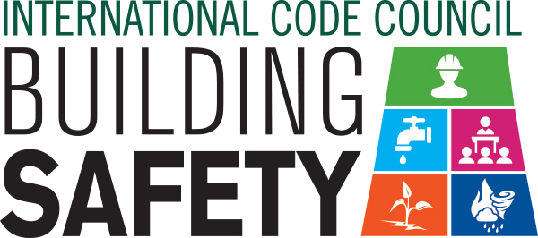

Sample News Release

Dear Member: This news release template will help you tell your residents and elected officials about Building Safety Month and the important role you play in the safety of your community. Fill in the appropriate information. Be sure to include any special events you will be holding in conjunction with Building Safety Month and, if available to you, seek assistance from your jurisdiction’s Public Information Officer. Distribute the release in April or early May to your local media. You can also post it on your website and use on Twitter, Facebook, LinkedIn and other social media websites.

For Immediate Release | Contact: Name Here
Month Day, 2018 | Contact Phone Number
Website URL | Contact Email

(Jurisdiction name) participates in worldwide campaign to promote building safety
(Insert subtitle about your local event/activities – ex. City XYZ is hosting a cook out on May XX at City Hall)

CITY, STATE – In May 2018, (Name of jurisdiction and department) is participating in the 38th annual Building Safety Month, a worldwide campaign presented by the International Code Council, its members and partners to promote building safety. First observed in 1980, Building Safety Month raises awareness about critical safety issues from structural to fire prevention, plumbing and mechanical systems, and energy efficiency.

Building codes and the officials who enforce them are making our families and communities safer and more resilient. Homes and buildings that are built in compliance with building safety codes result in resilient structures that minimize the risks of death, injury and property damage. In the wake of a disastrous hurricane season, rampant wildfires and devastating earthquakes, building safety is even more important. Building safety affects everyone, and modern, updated building codes save lives.

This year’s themes are: May 1–5, Partnering with Code Officials to Build Stronger, Safer Communities; May 6–12, Advancing Resilient Communities through Science and Technology; May 13–19, Protecting Communities from Disasters; May 20–26, Safeguarding Our Water; and May 27–31, Improving Education and Training Standards for a Safer Tomorrow.

Local events to celebrate Building Safety Month include (list any activities you have planned, including date, time and location).

“When our building safety and fire prevention experts inspect buildings and review construction plans to ensure code compliance, they help to ensure the places where you live, work and play are safe,” said (name of jurisdiction, your title, your first and last name). “We work closely with homebuilders, contractors, plumbers, roofers and other construction industry trades to provide for the public safety of our community.”

Building codes have protected the public for thousands of years. The earliest known code of law—the Code of Hammurabi, king of the Babylonian Empire, written circa 2200 B.C.—assessed severe penalties, including death, if a building was not constructed safely. The regulation of building construction in the United States dates back to the 1700s. In the early-1900s, the insurance industry and others with similar concerns developed the first model building code.

Today, the International Codes, developed by the Code Council and adopted by our community, are the most widely used and adopted set of building safety codes in the U.S. and around the world.

Learn more about Building Safety Month at www.buildingsafetymonth.org or join the conversation on social media at #ICCBSM18.

###

About (Insert Jurisdiction Name)
(Insert boilerplate language about your jurisdiction)

