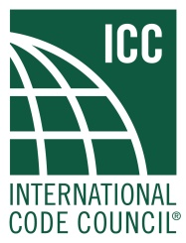

2019 ICC Honorary Members Call for Nominations

The ICC Board of Directors is requesting nominations for 2019 Honorary Members. An Honorary Member is a person who has rendered outstanding service to the ICC. The Honorary Member Committee will consider submitted nominations when compiling its list of candidates.
The Board of Directors will present its list of potential Honorary Members for approval by Governmental Member Voting Representatives in attendance at the Annual Business Meeting in Las Vegas, Nevada.
To nominate someone as an Honorary Member, please complete and email the form below to Karla Price Higgs, Vice President, Member Services, khiggs@iccsafe.org. The deadline to submit nominations for this year’s ICC Awards is March 15, 2019.

2019 ICC Honorary Membership Nomination Application

Name of Nominee:
Title:
eMail Address:
Telephone:
Jurisdiction/Organization/Company:

Brief explanation why this person should be considered for ICC Honorary Membership. Since an
Honorary Member is describe as a person who has rendered outstanding service to ICC, the
explanation should emphasize the nominee’s service to the International Code Council.:

Brief biography, previous awards, recognitions, etc., again emphasizing as much as possible recognitions
which show outstanding service to the ICC.

Name of the individual or organization presenting the nomination:

If organization, include contact name:
Address:
Telephone:
eMail Address:

