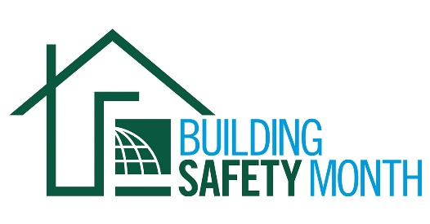

Sample Press Release

Dear Member: This news release template will help you tell your residents and elected officials about Building Safety Month and the important role you play in the safety of your community. Fill in the appropriate information. Be sure to include any special events you will be holding in conjunction with Building Safety Month and, if available to you, seek assistance from your jurisdiction’s Public Information Officer. Distribute the release in April or early May to your local media. You can also post it on your website and use on Twitter, Facebook, LinkedIn and other social media websites.

For Immediate Release | Contact: Name Here
Month Day, 2020 | Contact Phone Number
Website URL | Contact Email

(Jurisdiction name) joins International Code Council for the celebration of Building Safety Month 2020
(Insert subtitle about your local event/activities – ex. City XYZ is hosting a cookout on May XX at City Hall to promote building safety and resilience)

CITY, STATE – In May 2020, (Name of jurisdiction and department) will participate in the 40th annual Building Safety Month, a worldwide campaign presented by the International Code Council, its members and partners to promote building safety. This year’s campaign, “Safer Buildings, Safer Communities, Safer World,” highlights the importance of building codes for providing a strong and resilient built environment, and regularly updated codes that ensure that communities are protected in the face of disasters.

As we prepare ourselves for the increased severity and frequency of natural disasters, building safety is even more important. Disaster mitigation through the adoption and enforcement of building codes is one of the best ways for communities to prepare and protect against future disasters. Homes and buildings that are built in compliance with building safety codes and the officials who enforce the codes are essential to helping communities minimize the risks of death, injury and property damage in the event of a disaster.

This year’s campaign themes are: Week One, May 1-10, Disaster Preparedness; Week Two, May 11-17, Water Safety; Week Three, May 18-24, Resiliency. Sustainability. Innovation.; and Week Four, May 25-31, Training the Next Generation.

Local events to celebrate Building Safety Month include (list any activities you have planned, including date, time and location).

“The men and women that serve as building safety and fire prevention experts are heroes to our communities,” said (name of jurisdiction, your title, your first and last name). “They inspect buildings and review construction plans to ensure code compliance and to ensure the places where you live, work and play are safe.”

With an extensive history dating back to 2200 B.C and the Code of the Hammurabi, king of the Babylonian Empire, building codes have protected the public for thousands of years. The regulation of building construction in the United States dates back to the 1700s. Today, the International Codes, developed by the Code Council and adopted by our community, are the most widely used and adopted set of building safety codes in the U.S. and around the world.

Learn more about Building Safety Month at www.buildingsafetymonth.org or join the conversation on social media using #BuildingSafety365.

###

About (Insert Jurisdiction Name)
(Insert boilerplate language about your jurisdiction)

