ICC G5 - 2018

Guideline for the Safe Use of
ISO Intermodal Shipping Containers Repurposed
as Buildings and Building Components
Public Comment Draft
(7/20/18)

ICC G5 – 2018 Guideline for the Safe Use of
ISO Intermodal Shipping Containers Repurposed
as Buildings and Building Components

First Printing xxx 2018

Copyright © 2018
By
International Code Council, Inc.

ALL RIGHTS RESERVED. This ICC G5 – 2018 Guideline for the Safe Use of ISO Intermodal Shipping Containers Repurposed as Buildings and Building Components
is a copyrighted work owned by the International Code Council, Inc. Without advance written permission from the copyright owner, no part of this Guideline may be reproduced, distributed, or transmitted in any form or by any means, including, without limitation, electronic, optical or mechanical means (by way of example and not limitation, photocopying, or recording by or an information storage retrieval system). For information on permission to copy material exceeding fair use, please contact: Publications, 4051 West Flossmoor Road, Country Club Hills, IL 60478. Phone 1-888-ICC-SAFE (422-7233).

Trademarks: “International Code Council” and the “International Code Council” logo are trademarks of the International Code Council, Inc.
PRINTED IN THE U.S.A.
Image on cover: Rendering of container-based structure, courtesy of Radco, Inc, a Twining Company.

Preface
Introduction
The principal purpose of the ICC Guideline series is to provide a state-of-the-art volume of knowledge that will contribute to public health, safety and general welfare in the built environment. Guideline projects are established based on market relevancy, demand, and the realization that existing technical information, regulations or standards, if any, do not adequately address the subject or that such existing technical information needs to be enhanced, clarified and made more user friendly. ICC Guidelines are in-depth topic-specific technical publications that have global relevancy and may be used internationally. They are different from codes or standards in that they will generally use nonmandatory language.
Development
Development of the ICC Guideline series was approved by the ICC Board of Directors in September 2008. ICC Policy GP 33-08 governs the development of ICC Guidelines and can be viewed on the ICC website at www.iccsafe.org. ICC Guidelines are developed with the establishment of a Guideline Development Committee (GDC). The GDC is made up of a diverse stakeholder population and the participants are focused on ensuring high-quality and timely technical information for the built environment’s usage. Upon the GDC reaching consensus, the final draft is posted for a “Public Comment” period for 30 days. The GDC considers all public comments, revises the public comment draft as appropriate and sends its recommendations to ICC for publication.
Maintenance
ICC Guidelines are not required to be updated on a specific cycle; however, they will be reviewed periodically and may be updated through a GDC-established process as needed based on changing trends, technology or relevant technical information.
About this Guideline
ICC G5 – 2018 Guideline for the Safe Use of ISO Intermodal Shipping Containers Repurposed as Buildings and Building Components
The repurposed intermodal shipping container industry is a multi-billion-dollar market. There are currently over thirty million shipping containers in use around the world today.
These containers are now regularly being repurposed and converted into International Residential Code (IRC) and International Building Code (IBC) occupancy uses. As a “building material”, the applications are widely diverse as is the extent to which the container is used as a structural building element.

This Guideline is intended to help state and local jurisdictions—as well as owners, architects, builders and engineers— in their assessment as to how to design, review and approve such shipping containers as a building element.

Benefits of this Guideline:
- Local jurisdictions and state administrative programs are now reacting to the growing trend and are well behind in terms of regulations and compliance. A patchwork of regulations has emerged, creating potentially conflicting and duplicative requirements. This guideline is intended to provide guidance in this process.
- The development of this Guideline will greatly contribute to the health, safety, and welfare of the built environment. Aside from the ICC-ES AC 462 criteria, there are no codes, guidance, or references which exist to help code officials and the business industry navigate this process in a predictable and safe manner.
- Local AHJ’s need guidance as to what to look for and how to address such situations where new or repurposed containers are being considered as a building element in their jurisdiction.

About the International Code Council
The International Code Council (ICC), a membership association dedicated to building safety, fire prevention and energy efficiency, develops the codes and standards used to construct residential and commercial buildings, including homes and schools. The mission of ICC is to provide the highest quality codes, standards, products and services for all concerned with the safety and performance of the built environment. Most United States cities, counties and states choose the International Codes, building safety codes developed by the International Code Council. The International Codes also serve as the basis for construction of federal properties around the world, and as a reference for many nations outside the United States. The Code Council is also dedicated to innovation and sustainability and Code Council subsidiary, ICC Evaluation Service, issues Evaluation Reports for innovative products and reports of Sustainable Attributes Verification and Evaluation (SAVE).
Headquarters:
500 New Jersey Avenue NW, 6th Floor Washington, DC 20001-2070
Regional Offices:
Birmingham, AL
Chicago, IL
Los Angeles, CA
Telephone: 1-888-422-7233

www.iccsafe.org
Guideline Development Committee
Roland Brown, Ramtech Building Systems
Bill Bryant, CBO, MCP, Anne Arundel County, MD
Tom Hardiman, Modular Building Institute
Truong Huynh, P.E., C.B.O., Long Beach Development Services/Building Safety Bureau, CA
Michael Nugent, CBO, City of Rock Hill, SC
Guy Rodgers, CARU West Gulf Containers
Alt: Stephan Howard, Container Services International
Ara Sargsyan, P.E., C.B.O., LEED AP, Los Angeles Department of Building and Safety, CA
Mehdi Shadyab, P.E., CASp, J.D., City of San Diego, CA
Stephen Shang, Falcon Structure
Ralph Tavares, P.E., R&S Tavares Associates

Technical Support
Mike Pfeiffer, P.E., ICC
Michael Gardner, M Gardner Services, LLC (Rep: ICC)
Bill Gould, P.E., ICC - ES
William E. Koffel, PE, FSFPE, Koffel Associates, Inc. (Rep: MBI)
Table of Contents

Preface

About This Guideline

Development Committee

Introduction

Scope

Current Regulatory Environment

Industry Segments
Single-Unit vs. Multi-Unit Complexes
Temporary vs. Permanent

Current Code Requirements
Nonstructural
Structural

Referenced Standards

CSC Safety Approved Plate

Addressing the Interior of the Container and the Wood Floor Treatment

ICC-ES Acceptance Criteria for Structural Building Materials from Shipping Containers (AC462)

Appendix 1 State Modular Programs

Appendix 2 FAQ’s & Best Practices

Appendix 3 Code change G151-18 to the 2018 IBC

Appendix 4 Resources

Introduction

Today, the repurposed intermodal shipping container (container) industry is a multi-billion-dollar market. There are currently over thirty million International Standardization Organization (ISO) containers in use around the world today. These containers were built to ISO standards and maintained to standards defined by the International Maritime Organization’s (IMO) “Convention for Safe Containers”.

For industry participants, the main drivers of this segment are as follows: availability, safety and security (extremely hard to damage), strength and durability, designed for mobility, stackable, and speed of construction or installation.

Well-intentioned design professionals, builders and owners attracted by the idea of repurposing these containers have greatly publicized their use. The positive aspects of container conversion and the greater public awareness for recycling and everything eco-friendly has generated a lot of attention.

These drivers and factors have led to a broad array of applications and therefore different industry segments. These emerging segments are categorized as follows:

- Single-unit versus multi-unit
- Temporary versus permanent

Due to benefits such as environmental friendliness, availability, strength, and/or speed of construction, these containers are now regularly being repurposed and converted into uses and occupancies regulated by the International Residential Code (IRC) and International Building Code (IBC). The applications are widely diverse as are the extent to which the container is used as a structural building material. State and local jurisdictions are now reacting to the growing trend and are lagging in terms of the appropriate regulations to apply and how best to achieve a reasonable level of code compliance. A patchwork of regulations has emerged, creating potentially conflicting and duplicative requirements.

Despite the inconsistency at either the state or local levels, many design professionals, builders and owners have been able to demonstrate that projects utilizing containers complies with the general intent of the codes and are being approved throughout the country by code officials.
Scope

As with all ICC Guidelines, this guideline is not intended to be a regulatory document but rather a non-mandatory document that provides useful information for the industry, design professionals and code officials regarding intermodal shipping containers (containers) that are repurposed for use as buildings or structures or as part of buildings or structures.
Image above: container-based coffee/retail shop, courtesy of Radco, Inc, a Twining Company.

Many code officials, when presented with a request to use containers in their jurisdictions, are challenged in determining what is in the best interest of their community. Notwithstanding zoning issues that focus on the arrangement of compatible buildings and land uses in the interest of the social and economic welfare of their community, they are primarily concerned with the lack of clear and concise permitting requirements and appropriate standards that may apply to containers.

This guideline is intended to provide information and recommendations to those involved in the use of containers as buildings or structures in achieving a reasonable level of safety, public health and general welfare for the occupants.

Current Regulatory Environment

To understand the current regulatory environment for the repurposing of containers, it is important to recognize the relationship and role of the various entities at the state, local and national level that influence how a project is regulated and approved. The Modular Building Institute (MBI) is a non-profit trade organization that represents manufacturers, contractors, and fleet owners of both relocatable buildings and permanent modular construction projects. MBI contacted state and local jurisdictions to highlight their regulatory oversight for projects that use containers. In addition, MBI, code officials, and other interested parties are working together to develop, submit and get approve code change proposals that are intended to help facilitate these types of projects in the future.

State Level

The majority of states across the country that have some form of statewide modular building program or agency that regulates the construction and approval of residential and nonresidential buildings or structures (See Appendix 1). These programs or agencies vary in their interpretation of when and how a container may be modified and/or used as a building or structure or as a part of a building or structure. A few states do not allow the use of containers that are modified within their state. Some states allow the use of containers that are modified, provided the containers have first been evaluated in accordance with ICC-ES Acceptance Criteria for Structural Building Materials from Shipping Containers (AC462). Some states have an outright prohibition on their use, while others have certain exceptions or exemptions depending upon size and purpose.

The following are examples of some state laws or regulations governing or exempting the use of containers under specific conditions:
- California regulates containers that are modular and fabricated off-site, whether in-state or out-of-state, under their Factory-Built Housing Program or Commercial Modular Program through the Housing and Community Development Department. Where containers that are proposed to be used as modular school buildings, such projects are regulated through the Division of the State Architect.
- Georgia regulates any container that are intended for use as residential, commercial or industrialized buildings, including construction site office buildings with or without storage, and considering language that would require any containers to be manufactured not more than 48 months prior to its use as a building or building component.
- Maryland state law exempts industrialized buildings that are 8 body feet or less in width and 40 body feet or less in length that are used for business purposes, mobile offices or storage and not open to the general public from the requirements of their Industrialized Building Program administered by the Department of Housing and Community Development.
- Massachusetts only allows newly constructed US shipping containers under their modular program. The program does not allow the use of repurposed shipping containers.
- Ohio regulates containers modified off-site with concealed components through their Board of Building Standards’ Industrialize Unit (IU) Program.
- Texas allows repurposed shipping containers complying with the ICC-ES AC462 (see page 20) under their Industrialized Housing Building Program.

Local Jurisdiction Level

Similarly, MBI noted that local jurisdictions vary in their approach in regulating the use of containers as well. Many jurisdictions rely on their state’s regulations or codes to addressing the use of containers. Others may adopt model codes that are modified to fit the need of their community. Furthermore, locally adopted zoning ordinances may have design standards that impose restriction on materials and appearances that hinder the use of containers. Such ordinances tend to make the use of containers expensive and/or infeasible to construct or install.

The following are examples of some local jurisdiction’s laws or regulations governing or exempting the use of containers under specific conditions:

- City of Anchorage, “Policy AG.19, Intermodal Shipping Containers,” Anchorage Building Safety, Anchorage, Alaska, November 21, 2016.
- City of Long Beach, “Cargo Containers Used as Storage in Industrial Zones” and “Cargo Containers Adapted as a Building Material,” Building and Safety Bureau, Long Beach, California, Effective February 18, 2008 and November 27, 2012, respectively.
- City of Los Angeles, “Cargo Container Conversion to Building Modules,” Department of Building and Safety, Los Angeles, California, Effective 6/2017.
- City of Louisville, “Homeowner’s Permit Tool Box – A Check Guide to Permitting Your Shipping Container Project in Louisville Metro,” Louisville Metro Government Center, Construction Review, Louisville, Kentucky, no date.
- City of Portland, “Code Guide, Special Construction – IBC/3/#1 & IRC/1/#2,” Bureau of Development Services, Portland, Oregon, Effective January 29, 2013.
- City of San Diego, “Cargo Containers Information Bulletin 149,” Development Services, San Diego, California, Effective October 2015.
- City of Tioga, “Ordinance No. 295,” Grayson County, Texas, 2011.
- County of Grayson, “Ordinance No. 295,” City of Tioga, Grayson County, Texas, 2011.
- County of Yakima, “Cargo Containers, Shipping Containers, Trailers, Storage Units, Ordinance Chapter 19.18,” Yakima County Public Services, Building & Fire Safety Division, Yakima, Washington, Revised 3/30/2017.

National Level

Despite the absence of clear and uniform guidance and a patchwork of emerging regulations, containers used as buildings or structures will continue towards gaining acceptance with code officials at both the state or local level. Recognizing the need to develop clear and reasonable code language to ensure uniformity of application and enforcement of regulations for containers, efforts are underway by members of the ICC’s Building Code Action Committee (BCAC) to develop proposed code changes to the 2018 Edition of the International Building Code (IBC) that are intended to help both design professionals and code officials in evaluating and approving future projects using containers. The codes used throughout the country are updated and published every three years by ICC.

2018 marks the beginning of the code development cycle. As such, code change proposals are submitted to ICC at the beginning of the year in early January. The code change proposal for containers is G151-18. ICC holds Committee Action Hearings (CAH) during the latter part of April to consider the code change proposals, make modification to the proposals, and vote on the proposals. The General Code Committee, which is the body that heard the proposal for the containers, voted to approve the code change proposal As Modified with specific modifications during the CAH process. After the close of the CAH and upon issuance of a Report of the Committee Action Hearing, interested parties and stakeholders may submit comments on this code change proposals by mid-July. Any comments received will be further discussed during the Public Comment Hearings (PCH) in late October, followed by a vote of the eligible voting members of ICC in October/November. If approved, the code change proposal for the container will be incorporated into the 2021 Edition of the IBC. See Appendix 3 for more information on the code change proposal.

In absence of the code development process currently underway, projects utilizing containers as buildings or structures will in the interim continue towards gaining acceptance with code officials at both the state or local level when it can be demonstrated to be in general compliance with the codes.

Industry Segments
There are multiple uses and applications for intermodal shipping containers (containers), each with its own need for segmentation and discussion. For example, there are distinctions between containers used as temporary, single-unit ground level offices vs. containers used as building components for multi-unit, permanent building or structure. Similarly, there needs to be a distinction for containers used as permanent buildings or structures that incorporates enclosed utilities (e.g., electrical, plumbing, mechanical, etc.) vs. containers used primarily as structural elements of a building or structure. Based on these distinctions, four industry segments have been identified that will help to guide the codes and regulations that are being developed. (See Exhibit A on following page).

Single-Unit vs Multi-Unit
There needs to be a distinction between a single-unit container that is modified and used as a temporary relocatable building compared to multi-unit containers that are modified and used as a building material or component to create a larger building or structure. Recognizing this difference, some states and local jurisdictions have amended the model codes and/or their administrative programs to provide for exemptions based on the size and scope of the containers that are used. Similarly, a code change proposal has been introduced for the 2021 Edition of the IBC to provide a simplified approach to the structural design of single-unit containers vs. multi-unit containers that may be more complex and requires a more detailed structural analysis and design.

Temporary vs Permanent
For the purposes of determining the extent of compliance to the building code, code officials generally refer to Section 108.1 of the IBC to determine if a container is temporary or permanent. Specifically Section 108.1 of the IBC allows code officials to issue a permit for temporary structures up to 180 days with a provision allowing for further extensions for demonstrated cause. Containers that are not considered temporary are by default considered permanent.

Section 108.2 of the IBC requires temporary structures to conform to requirements of the building code as necessary to ensure public health, safety, and general welfare, while not requiring full compliance with the provisions of the building code. For example, containers that are treated as temporary may not require a permanent foundation. Conversely, where containers are determined to be permanent, code officials may require full compliance with the building code.

The determination of whether containers are viewed as temporary vs. permanent may vary from state to state or jurisdiction to jurisdiction. The City of San Diego and the City of Long Beach, for example, currently provides for an exemption for containers when “used temporarily on a site for and during construction of a building having a valid building permit…” as well as an exception for units when “used for equipment/storage/props during a permitted special event”. It is recommended that design professionals and owners have early discussion with the code officials to determine if the containers are temporary or permanent.

Additionally, some states provide an outright exemption based on occupancy classification and use. Construction site offices, not open to the general public, are often exempted for the requirements of the building code and many state modular administrative programs.

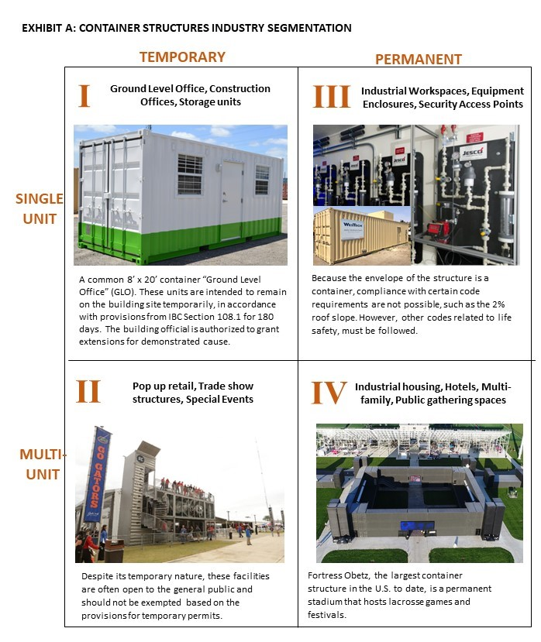
Images courtesy of Falcon Structures (I, III, IV) and Boxman Studios (II)
Current Code Requirements

Currently, shipping containers may be used as an alternative building material which can be used as a building component subject to the requirements of the code. Because procedures vary from location to location, prospective developers and builders should consult their local government authority to gain an understanding of the state and local laws and regulations as well the required technical submissions for development review and approval.

There are multiple approaches that a design professional, builder or owner can take in order to demonstrate compliance with the rules is effect in a jurisdiction. Similarly, code officials may need to rely on other consensus standards or documents to assist them in properly evaluating what aspect of the codes to apply, if appropriate, when regulating projects, that are going to repurpose containers as buildings or structures.

When containers are presented to the authority having jurisdictions for use as buildings or structures or as structural building materials, it is important to understand the general process by which they are reviewed and approved by code officials. Containers, like any other building or structure, are required to comply with the codes (such as but not limited to IBC, IRC, IFC, IEBC, etc.). The codes generally addresses structural strength, means of egress, sanitation, adequate lighting and ventilation, accessibility, energy conservation and life safety in regard to new and existing buildings, facilities and systems. The first step in the permitting process starts with a well prepare construction document by a registered design professional. Construction documents are defined in the codes as written, graphic and pictorial documents prepared or assembled for describing the design, location and physical characteristics of the elements of a project necessary for obtaining a building permit. This generally means that construction documents should contain information necessary to ascertain code compliance, including but not limited to, verifying the dimensions and establishing the physical properties of the container’s steel and wood floor components, in addition to any other information that may be required in Section 107 of the IBC.

There are multiple approaches that a registered design professional, builder or owner can take to demonstrate compliance to the code officials. Similarly, code officials may need to rely on other consensus standards or documents to assist them in properly evaluating what aspect of the codes to apply, if appropriate, when regulating containers that are going to be repurposed as buildings or structures or as structural building materials. The following nonstructural and structural topics outlined herein provides a general highlight of some important design features to consider in preparing construction documents for compliance to the codes.

Non Structural
The International Codes contain regulations for the non-structural elements of a project.

Buildings that are detached one- and two-family dwellings or townhouses not more than three stories above the grade plane fall under the scope of the IRC. This code also has chapters that deal with virtually all trades in residential construction. The IRC provides direction for means of egress, smoke and carbon monoxide detection, energy standards, fire resistant construction, room dimensions and sanitation.

All other structures fall under the scope of the IBC. The nonstructural guidelines are similar to those found in the Residential Code. The IBC also addresses the requirements noted below. Beyond the scope of the IRC and IBC, another difference is that the IBC is primarily a building code. There are a host of other International Codes and the National Electrical Code that regulate the other trades.

- General Nonstructural. Construction documents should show the following basic information (as applicable): project address, legal description of the lot, total floor area, type of construction, number of stories, use and occupancy, fire separation distance or setback to property lines or other buildings and structures on the lot, lot size and dimensions, location of street or alley, parking spaces, etc. At minimum, this information will assist the code officials in determining which aspect of the codes are applicable to the containers.
- Use and Occupancy Classification. Chapter 3 of the IBC provides for the classification of containers that are repurposed as buildings or structures. Defining the use and occupancy of containers is important as it sets the applicable standards for such design issues like allowable height, floor areas, number of stories, potential fire hazard levels, fire protection and means of egress system.
- Types of Construction. Chapter 6 of the IBC establishes the type of construction that containers are to be classified as. There are 5 types of construction classification ranging from Type I (highest fire-resistance rating, noncombustible) to Type V (lowest fire-resistance rating, combustible). The higher the type of construction, the higher the allowable height, floor area and stories permitted for containers.
- Fire Protection System. Chapter 9 of the IBC and IFC prescribes the minimum requirements for active systems of fire protection equipment. Generally, the requirements are based on the occupancy, the height and area of containers, because these are the factors that most affect fire-fighting capabilities and the relative hazards of a specific building.
- Means of Egress. Chapter 10 of the IBC set forth general criteria for the design of the exiting scheme as the primary method for protection of people in containers by allowing timely relocation or evacuation of building occupants. Both prescriptive and performance language is utilized to provide a basic approach in the determination of a safe existing system for all occupancies.
- Interior Environment. Chapter 12 provides minimum standards for the interior environment of containers. The standards address the minimum sizes of spaces, minimum temperature levels, minimum light and ventilation levels, limiting sound transmission through walls/floors/ceilings, ventilation of under floor spaces, and toilet/bathroom construction.

Structural

The IRC and IBC provide specific structural regulations such as wind, seismic and snow loading based on location and use, soils and foundation loads, live loads for building systems based on use and occupancy. Structural designs featuring shipping containers will need to satisfy all applicable structural provisions.

In Appendix 3, the proposed IBC code change to create the new “Intermodal Shipping Container” regulation, is a glimpse into what may be part of the industry standard in the 2021 IBC.

Regardless of the type of project, from a design and regulatory perspective, there are challenges. The designer must provide details that establish structural integrity and fire/life safety. Once modified, the unit becomes a building material component. Similar to a roof or floor truss, the modified unit needs to be engineered to perform when subject to the live and dead loads imposed. The design for the connections, structural compensation for openings and additional dead loads from desired and required building features must be included.
- General Structural. Construction documents should show the following basic structural information (as applicable): size, section and relative locations of structural members of containers with floor levels, column centers and offset dimensioned. The steel members containers furnished for structural load-carrying purposes should be properly identified for conformity to the ordered grade in accordance with the specified ASTM standards adopted in Chapter 35. Any material of questioned suitability may be subjected to the test prescribed in Chapter 17 of the IBC and in the approved rules to determine character, quality and limitations of use. The steel members of containers that are not readily identifiable as to grade from marking and test records may be tested to determine conformity to such standards when required by code officials.
- Structural Design. Chapter 16 of the IBC prescribes minimum structural loading requirements for use in the design of containers. It includes minimum design loads, assignment of risk categories, and permitted design methodologies to enhance the protection of life and property. This chapter references and relies on many nationally recognized design standards.
- Special Inspections and Tests. Chapter 17 of the IBC provides a variety of procedures and criteria for testing materials and assemblies, labeling materials and assemblies and special inspection not structural assemblies. Standards for special inspection, testing and reporting of the containers’ structural components and quality of materials to the code officials are provided in this chapter.
- Soils and Foundation. Chapter 18 of the IBC provides criteria for geotechnical and structural considerations in the selection, design and installation of foundation systems to support the loads from the containers above. Due care must be exercised by the registered design professional in the planning and design of foundation systems based on obtaining sufficient soils information, the use of accepted engineering procedures, experience of good technical judgment.
- Steel. Chapter 22 provides the requirements necessary for the design of containers’ structural steel, cold-formed steel, steel joists, etc. Appropriate design and construction standards as specified in this chapter.

One of the challenges for code officials is the lack of information on material properties and specifications related to the steel elements of a container. As those elements are for structural load-carrying purposes, it needs to be properly identified for conformity to the ordered grade in accordance with the specified ASTM standards adopted in IBC Chapter 35 (Reference Standards) and the provisions of IBC Chapter 22 or other specification as approved by the code official. Since a majority of the steel elements are from foreign countries and not necessarily constructed to standards adopted in the United States, investigating and identifying the material properties and converting them to acceptable US standards will help code officials in accepting the use of containers for structural purposes. Any material of questioned suitability proposed for use in the construction of a building should be subjected to the test prescribed in IBC Chapter 22 (Steel) and in the approved rules to determine character, quality and limitations of use. The steel elements of a container that is not readily identifiable as to grade from marking and test records shall be tested to determine conformity to such standards. A factor in determining the extent of the investigation into identifying material properties and specifications depends on whether containers are used in multi-unit configuration or as a single-unit stand-alone.
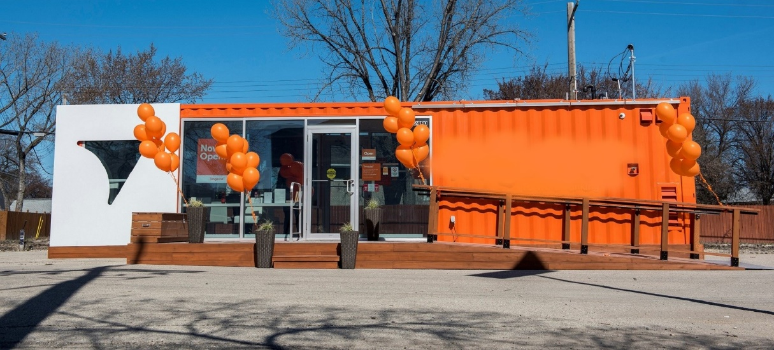

Image above – container-based structure used for temporary retail application. Courtesy of Modular Building Institute
Referenced Standards

The Convention for Safe Containers (CSC) is an international agreement resulting from the 1972 International Convention for Safe Containers. The countries adopting CSC are known as Contracting Parties. The United States, for example, is a contracting party. The CSC is administered by the governments of the Contracting Parties or by organizations designated by the governments such as Classification Societies. The selected Classification Society inspects the containers at the point of manufacture, and if they pass the inspection, places a CSC Safety Approval Placard on each container and assigns a unique CSC safety approval number. The inspected containers will have the selected Classification Society’s decal affixed to them.

It should be recognized that the codes does not reference international treaties as part of its regulations. However, code officials have the option of relying on the “approved agency” language in Section 104.4 of the IBC as the bases to recognize and accept the work of Classification Societies. Approved agency as defined in Chapter 2 of the IBC means an established and recognized agency that is regularly engaged in conducting tests or furnishing inspection services, where such agency has been approved by code officials.

In the United States, the American Bureau of Shipping (ABS) is one such organization designated to administer this international adopted agreement and the standards referenced therein. Approvals under the authority of a Contracting Party are accepted by other Contracting Parties. As a result, containers can operate worldwide under a single set of safety regulations.

ABS is one of The International Association of Classification Societies (IACS), which is a technically based non-governmental organization that currently consists of twelve member marine classification societies. More than 90% of the world's cargo-carrying ships’ tonnage is covered by the classification standards set by member societies of IACS.

Marine classification is a system for promoting the safety of life, property and the environment primarily through the establishment and verification of compliance with technical and engineering standards for the design, construction and life-cycle maintenance of ships, offshore units and other marine-related facilities. These standards are contained in rules established by each Society. IACS provides a forum within which the member societies can discuss, research and adopt technical criteria that enhance maritime safety.

List of the Classification Societies
Name | Abbreviation
American Bureau of Shipping | ABS
Bureau Veritas | BV
China Classification Society | CCS
Croatian Register of Shipping/ Austrian Veritas (Hrvatski Registar Brodova) | Not applicable
DNV GL | DNV GL
Indian Register of Shipping | IR Class
Korean Register of Shipping | KR
Lloyd's Register | LR
Nippon Kaiji Kyokai (ClassNK) | NK
Polish Register of Shipping (Polski Rejestr Statków) | PRS
Registro Italiano Navale | RINA
Russian Maritime Register of Shipping (Российский морской регистр судоходства) | RS

CSC sets international standards in two areas:
• Design type approval to ensure that new containers are designed and built to meet the dimensional and strength requirements established by the International Standards Organization (ISO).
• Safety inspections to ensure that containers are maintained in safe condition during their operating lives.

The specific ISO standards (International Organization for Standardization) for containers that are the most pertinent to recognize are ISO 1496-1, ISO 6346, and ISO 668. Among other things, these ISO standards ensures that every container constructed must meet a rigorous set of requirements to receive an approval by a selected Classification Society.

ISO Standards
Standard Reference Number | Title
ISO 1496 – 1:2013 | Series 1 Freight Containers – Specification and Testing Part 1: General Cargo Containers for General Purposes
ISO 6346: 1995, with Amendment 3: 2012 | Freight Containers – Coding, Identification and Marking
ISO 668: 2013 | Series 1 Freight Containers – Classifications, Dimensions and Ratings

The following is a general overview of those pertinent ISO standards:

ISO 1496-1 is the standard that establishes both static and dynamic test loads for the construction of containers. The following are the types of tests:

Test No.1 – Stacking
Test No.2 - Lifting from the four top corner fittings
Test No.3 - Lifting from the four bottom corner fittings
Test No.4 - Restraint (longitudinal)
Test No.5 - Strength of end walls
Test No.6 - Strength of side walls
Test No.7 - Strength of the roof
Test No.8 - Floor strength
Test No. 9 - Rigidity (transverse)
Test No. 10 - Rigidity (longitudinal)
Test No. 11 - Lifting from fork-lift pockets
Test No. 12 - Lifting from the base at grappler arm positions
Test No. 13 – Weather Proof

ISO 6346 is the standard that establishes how the container is to be identified with the relevant coding, identification and markings. The culmination of this information is placed onto a CSC Safety Approval Placard.

ISO 668 is the standard that established the dimensional requirements and tolerances for the construction of containers.

Image below: two-story container-based structure used for classroom/meeting space. Courtesy of Modular Building Institute

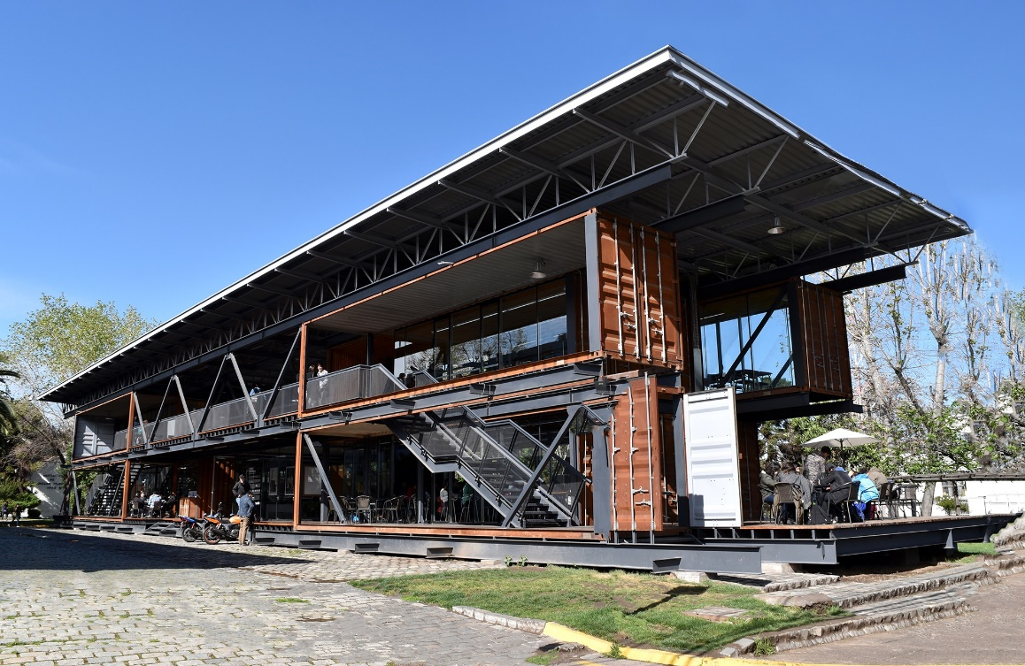
CSC Safety Approval Placard
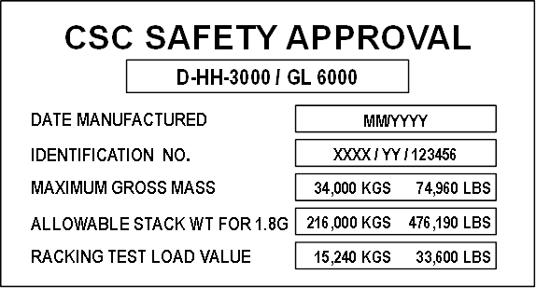

Containers that are built, tested and inspected to ISO standards by a Classification Society are affixed with a CSC Safety Approval Placard located at the rear door of the containers. This Safety Approval Placard, or data plate as commonly referred to by code officials, provides useful information such as the container’s identification, inspection examination date, and ensure that containers are maintained in safe condition during their operating life. (See Figure). The information contained on the data plate includes, but not limited to, the following:
• Manufacturer's name or identification number
• Date manufactured
• Safety approval number
• Identification number
• Maximum operating gross mass or weight (kg)(lbs)
• Allowable stacking load for 1.8G (kg)(lbs)
• Transverse racking test force (Newtons)
• Valid maintenance examination date

Code officials can reasonably rely on this data plate to confirm that a container was built and inspected to the appropriate ISO standards. Design assumption derived from the testing loads in ISO 1496-1 that registered design professionals may use are contingent on the code officials accepting that the containers based on whether the data plate is current and valid for that specific container. Without the data plate, code officials are placed in a difficult position of confirming or verifying by other methods as to the quality and reliability of the unknown containers.

It is recommended that the register designer professionals, builders and owners who are looking to use and repurpose containers seek to ensure that prior to purchasing or acquiring containers to determine that it have it original data plate still affixed to the rear doors. Removing the data plate or selecting containers that do not have them may lead the code officials to reject and not accept the containers. Upon receiving this confirmation or acceptance by code officials, retention of the data plate after the modification of the containers are no longer required. At that point and after modifications have been made to containers, the information represented on the data plate is no applicable.
Addressing the Interior of the Container and the Wood Floor
As with many repurposed materials, questions about the previous use and construction of shipping containers arise on occasion.
The issues presented typically focus on two topics: one, how can I become comfortable about what was transported in the container during cargo conveyance and, two, does the wood floor in a container need to be addressed?
Shipping containers used for cargo conveyance are strictly regulated during use. These regulations require the proper packing, securing, storing and segregating of any hazardous materials as well as for inspections to be performed at loading and unloading locations and when units are returned to a depot for repair and storage. As a result, it is highly unlikely that a contaminated container would make it into the marketplace.
Receiving a cargo worthy designation during inspection ensures the unit meets all the guidelines provided by IMO, ISO, IMDG and CSC most of which are promulgated in the United States by Code of Federal Regulation Section 49 on transportation, and enforced by the U.S. Coast Guard.
As an added measure, many state modular/industrialized building programs require that the manufacturer have a quality control/quality assurance program in place (QC/QA). Third party inspection agencies (TPIA), or third-party quality assurance agencies review the manufacturer’s practices to determine if they are in compliance with their own QC program. The third-party agency approval includes an inspection of the QA program with regard to procedures and protocols the manufacturer is using to mitigate this risk.
As with any repurposed material, a container should be thoroughly cleaned and sanitized prior to re-use. Depending on its final use, re-coating of the interior of the container with a sealant or paint, appropriate for the intended use, may be appropriate.
THE FLOOR
A wood platform floor is installed in the container during manufacturing. Typical container exposure to a variety of climatic conditions during use and transit necessitates that floors are typically constructed using marine lumber, treated to prevent environmental degradation and insect infestation. It is the presence of the wood treatment substances that can muddle the container re-use process.
To assess the floor, first evaluate the intended future of the container. If the container will have a static use that does not require repeated access to the interior of the unit – for example, a container that is being used as a storage unit or equipment shed – the floor likely can remain in place, because the container is essentially replicating its life as a shipping unit. The same approach may also be appropriate for a container intended for short-duration temporary use or a permanent use that does not involve significant direct contact with the floor.
Multiple options are available if it is determined that the floor will remain in the container and concerns about the floor exist.
One option is to use the container flooring as a subfloor and install another floor covering on top of it, or if the container flooring is in good condition, to seal the treated wood. In this instance, direct contact would be non-existent or minimal as the flooring would either be underneath another material or would be sealed with polyurethane or other sealant material.
Note that during renovation, removal, or repair activities, inhalation of treated wood dust – in particular, if the floor is sanded as part of the re-use operation - could be of concern. The use of appropriate personal protective equipment, as mandated by local or federal statute, is recommended. Subsequent to renovation or removal, all surfaces should be cleaned to facilitate application of any topping materials and to remove any traces of dust or wood fragments.
Another option is to analyze the wood floor for wood treatment residue. One source of analysis is a study conducted by The National Portable Storage Association (NPSA). The study was conducted by the environmental consulting firm of TRC in Windsor, Connecticut in October 2017. It evaluated four commonly used wood treatment products approved for glue-line treatment of veneer-based plywood.
The study concluded that there is minimal to no health risk due to the treated flooring used in storage containers. Additionally, it is TRC’s best professional judgement that actual testing of the storage containers is unnecessary. To access the full published study, please contact the NPSA. See appendix 4.
In any instance where the floor is to remain in the container, examine the floor and its structure to determine that both are in appropriate condition and the unit is safe for the intended use. If the final decision is to retain the floor, remove or replace damaged or inadequate flooring or structural members.
Additional information is contained in the FAQs that supplement this document.

ICC-ES Acceptance Criteria for Structural Building Materials from Shipping Containers (AC462)
ICC-ES is a nonprofit, limited liability company, and the United States’ leading evaluation service for innovative building materials, components and systems. ICC-ES Evaluation Reports (ESRs), provide evidence that products and systems meet requirements of codes and technical standards. Evaluation reports issued by the ICC-ES are based upon performance features of the International family of codes and Section 104.11 of the IBC and Section R104.11 of the IRC. Section 104.11 provides Authorities Having Jurisdiction (AHJ) latitude to allow materials and methods of construction that are not addressed therein. With new products continually being introduced for industry use, this allowance is needed to promote rather than hinder innovation.
In February 2016, ICC –ES introduced AC462 which established criteria and a protocol for evaluating the reuse of shipping containers as a source of building materials. For any new building constructed in whole or in part from existing ISO shipping containers, ICC-ES AC462 is an acceptable starting point.
ICC-ES AC462 is not intended to be used retroactively to assess an existing building constructed from shipping containers, as modifications have already been made to the container. Additionally, while ICC-ES AC462 represents the most common and accepted path towards compliance, it is not the only path available to determine the safe use of modified shipping containers as new buildings or building components. The purpose of this guideline is to provide local code officials with information and guidance on the various approval methods available.
ICC-ES AC462 was approved by the Evaluation Committee and provides interested parties with criteria for demonstrating compliance with the performance features of the code. It is important to note that ICC-ES AC462 evaluates shipping containers to be used as the source of building materials for constructing building modules, and not the final building approval.
The development of product evaluation reports and Acceptance Criteria is an on-going process. As a consequence, AC462 may be modified via the ICC-ES review process at a point in the future. The Acceptance Criteria creation and modification process incorporates open, public hearings and encourages public input.

Appendix 1
State Modular Programs
State | Agency
AL | Manufactured Housing Commission
AZ | State Fire Marshal
CA | Housing & Community Development
CO | Division of Housing
FL | Business & Professional Regulations
GA | Dept of Community Affairs
ID | Division of Building Safety
IL | Department of Public Health
IN | Dept of Homeland Security/SFM
KY | Department of Housing
LA | State Fire Marshal
MA | BBRS/Manufactured Building Program
MD | Department of Labor, Licensing and Regulations
MI | Bureau of Construction Codes
MN* | Department of Labor & Industry
MO | Public Service Commission
MT | Department of Labor & Industry
NC | Department of Insurance/SFM
ND* | Department of Commerce
NH | State Fire Marshal
NJ* | Dept of Community Affairs/Bureau of Code Services
NM | Construction Industry Codes Div.
NV | Department of Business & Industry
NY | Department of State
OH | Building Codes Division
OR | Building Codes Division
PA | Department of Labor & Industry for commercial modular. Department of Community & Econ Development for residential.
RI* | Building Code Commission
SC | Department of Labor
TN | Department of Commerce
TX | Industrialized Housing
UT | Factory Built Housing
VA | Housing & Community Development
WA | Department of Labor & Industry
WI | Department of Commerce
*States participating in the Interstate Industrialized Buildings Commission, a multi-state administrative agency for modular/industrialized buildings.

Appendix 2
FAQ’s and Best Practices
Q. I own existing ground level offices made from modified containers (container-based structures). Can I continue to use these container-based structures?
A. It depends on whether these existing container-based structures were built to a previous version of the code and/or built in accordance with one of the state modular/industrialized building programs. If not, these container-based structures are subject to the code as enforced by the authority having jurisdiction.

Q. Does my existing container-based structure have to be brought up to code when moved or relocated to another site or location?
A. Existing buildings are commonly addressed in the International Existing Building Code (IEBC). The 2018 IEBC defines an existing building as “a building erected prior to the date of adoption of the appropriate code or one for which a legal building permit has been issued”. Within the IEBC, Chapter 14 addresses relocatable buildings, requiring them to meet all the site requirements and conditions, such as seismic, snow, and wind loads as well as appropriate foundation requirements.

Q. Can I get an ICC-ES Evaluation Services Report (ESR) to establish that my existing container can be used as a building?
A. The issuance of an ESR for a shipping container is based on the requirement of the Acceptance Criteria for Structural Building Materials from Shipping Containers (AC462). The intent of AC462 is to evaluate the quality control procedures used to establish and verify the dimensions, chemical and physical properties of the steel components of the shipping containers, and to evaluate the steel components for design in accordance with the provisions of the code.

Q. Am I required to get an ESR in accordance with ICC-ES AC462 to use containers as structural building materials?
A. No. ICC-ES AC462 represent one method to establish and verify the dimensions, chemical and physical properties of the steel components of the shipping containers. There may be other methods if approved by the authority having jurisdiction.

Q. What is the process to determine the presence of other possible chemicals or toxins, such as those used in the packing materials, contained in the shipped cargo, or used in the construction of the container itself?
A. There are several numbers of national and international protocols and procedures in place by the shipping container industry that minimize the chance that a contaminated container could not be properly cleaned. Some example includes:
International Maritime Dangerous Goods (IMDG) Code – Developed by the International Maritime Organization (IMO) a specialized agency of the United Nations. IMO is the global standard-setting authority for the safety, security and environmental performance of international shipping. Its main role is to create a regulatory framework for the shipping industry that is fair and effective, universally adopted and universally implemented. The IMDG Codes are accepted as an international guide to the transport of dangerous goods by sea and made mandatory in 2002. See IMO in resources section for more information.
U.S. Customs and Border Patrol and the U.S. Environmental Protection Agency - The importation of toxic chemical substances is regulated by the U.S. Environmental Protection Agency (EPA). Commercial importation of chemical substances must comply with the Toxic Substances Control Act (TSCA). All importations of chemicals require a TSCA statement. The importer is required to certify either that the shipment is subject to TSCA and complies with all applicable rules and orders, or that the chemical shipment is not subject to TSCA by filing and signing with Customs and Border Protection (CBP). CBP must receive the statement in order to release the shipment. In short, the EPA and US Customs and Border Patrol already regulate the shipment of hazardous materials.
Q. How high can I stack my containers?
A. Most shipping containers are originally designed and tested to stack 9 containers high when used for shipping cargo and which contains 66,000 pounds of cargo. With proper structural engineering analysis and design, containers used as buildings or structures can be engineered to stack as high as the code allows.

Image: Four-story hotel constructed utilizing shipping containers. Courtesy of Modular Building Institute.
Q. How are the existing stock of relocatable building units being utilized?
A. There are currently about 350,000 existing relocatable building units owned and leased by the modular industry. These units are used as construction site offices, security offices and classroom spaces. MBI estimates about 15-20% of industry owned relocatable buildings are modified shipping containers. This number does not include the number of units owned by construction companies, school districts, or other private companies. MBI expects this percentage to increase as older wood framed relocatable buildings are taken out of service and replaced with container units.
Q. What type of construction would container-based structures or structures be classified?
A. In most cases, it is appropriate to classify container-based structures or structures as a Type VB construction. With appropriate modifications, container-based structures or structures can be classified as any other types of construction. Refer to the IBC Chapter 6 for additional information.

Q. Can a container-based structure have any use or occupancy?
A. There are no restriction on the type of use or occupancy allowed within a container-based structure provided all applicable code requirements for that specific use or occupancy are satisfied.

Q. What is the fire-resistance rating for shipping container walls?
A. There has been no conclusive study or testing performed to determine what the minimum fire-resistance rating is for container walls, roof and floor. As such, any determination for fire-resistance rating may require performance testing to be conducted or other methods approved by the authority having jurisdiction.

Appendix 3
Code change G151-18 to the 2018 IBC
This appendix is not subject to the Guideline public comment process.
The following is a code change to the 2018 International Building Code (IBC) submitted by the Building Code Action Committee to address shipping container issues in the IBC. This proposal was approved as modified at the Columbus Committee Action Hearing (modifications included in the text). It is subject to change via the ICC Code Development Process which includes the Public Comment Hearing (PCH) which will occur October 24 – 31, 2018, followed by the Online Governmental Consensus Vote. If approved (final results should be known in December/2018), the resulting text will be included in the 2021 IBC.
For more information about the 2018 Cycle, click here.
Add new definition as follows:

INTERMODAL SHIPPING CONTAINER. A six-sided steel unit originally constructed as a general cargo container used for the transport of goods and materials.

Revise as follows:
3101.1 Scope. The provisions of this chapter shall govern special building construction including membrane structures, temporary structures, pedestrian walkways and tunnels, automatic vehicular gates, awnings and canopies, marquees, signs, towers, antennas, relocatable buildings, swimming pool enclosures and safety devices, and solar energy
systems and intermodal shipping containers.

Add new text as follows:

SECTION 3114 INTERMODAL SHIPPING CONTAINERS

3114.1 General. The provisions of Section 3114 and other applicable sections of this code, shall apply to intermodal shipping containers that are repurposed for use as buildings or structures or as a part of buildings or structures.

Exceptions:
1. Intermodal shipping containers previously approved as existing relocatable buildings complying with Chapter 14 of the International Existing Building Code.
2. Stationary storage battery arrays located in intermodal shipping containers complying
with Chapter 12 of the International Fire Code.
3. Intermodal shipping containers that are listed as equipment complying with the standard for equipment, such as air chillers, engine generators, modular data centers, and other similar equipment.
4. Intermodal shipping containers used as experimental equipment or apparatuses.

3114.2 Construction Documents. The construction documents shall contain information to verify the dimensions and establish the physical properties of the steel components, and wood floor components, of the intermodal shipping container in addition to the information required by Sections 107 and 1603.

3114.3 Intermodal shipping container information. Intermodal shipping containers shall bear an existing data plate containing the following information as required by ISO 6346 and verified by an approved agency. A report of the verification process and findings shall be provided to the building owner.
1. Manufacturer's name or identification number
2. Date manufactured.
3. Safety approval number.
4. Identification number.
5. Maximum operating gross mass or weight (kg) (Lbs)
6. Allowable stacking load for 1.8G (kg) (lbs)
7. Transverse racking test force (Newtons)
8. Valid maintenance examination date

Where approved by the building official, the markings and existing data plate are permitted to be removed from the intermodal shipping containers before they are repurposed for use as buildings or structures or as a part of buildings or structures.

3114.4 Protection against decay and termites. Wood structural floors of intermodal shipping containers shall be protected from decay and termites in accordance with the applicable provisions of Section 2304.12.1.1.

3114.5 Under-floor ventilation. The space between the bottom of the floor joists and the earth under any intermodal shipping container, except spaces occupied by basements and cellars, shall be provided with ventilation in accordance with Section 1202.4.

3114.6 Roof assemblies. Intermodal shipping container roof assemblies shall comply with the applicable requirements of Chapter 15.

Exception: Single-unit stand-alone intermodal shipping containers not attached to, or stacked vertically over, other intermodal shipping containers, buildings or structures.

3114.7 Joints and voids. Joints and voids that create concealed spaces between intermodal shipping containers, that are connected or stacked, at fire-resistance-rated walls, floor or floor/ceiling assemblies and roofs or roof/ceiling assemblies shall be protected by an approved fire-resistant joint system in accordance with Section 715.

3114.8 Structural. . Intermodal shipping containers which conform to ISO 1496-1 that are repurposed for use as buildings or structures, or as a part of buildings or structures, shall be designed in accordance with Chapter 16 and this section.

3114.8.1 Foundations. Intermodal shipping containers repurposed for use as a permanent building or structure shall be supported on foundations or other supporting structures designed and constructed in accordance with Chapters 16 through 23 of this code.

3114.8.1.1 Anchorage. Intermodal shipping containers shall be anchored to foundations or other supporting structures as necessary to provide a continuous load path for all applicable design and environmental loads in accordance with Chapter 16.

3114.8.2 Welds. All new welds and connections shall be equal to or greater than the original connections.

3114.8.3 Structural design. The structural design for the intermodal shipping containers repurposed for use as a building or structure, or as part of a building or structure, shall comply with Section 3114.8.4 or 3114.8.5.

3114.8.4 Detailed design procedure. A structural analysis meeting the requirements of this section shall be provided to the building official to demonstrate the structural adequacy of the intermodal shipping containers.

Exception: Intermodal shipping containers designed in accordance with Section 3114.8.5.

3114.8.4.1 Material properties. Structural material properties for existing intermodal shipping container steel components shall be established by material testing where the steel grade and composition cannot be identified by the manufacturer's designation as to manufacture and mill test.

3114.8.4.2 Seismic design parameters. The seismic force-resisting system shall be designed and detailed in accordance with one of the following:

1. Where all or portions of the corrugated steel container sides are considered to be the seismic force-resisting system, design and detailing shall be in accordance with the ASCE 7 Table 12.2-1 requirements for light-frame bearing-wall systems with shear panels of all other materials,
2. Where portions of the corrugated steel container sides are retained, but are not considered to be the seismic force-resisting system, an independent seismic force-resisting system shall be selected, designed and detailed in accordance with ASCE 7 Table 12.2-1, or
3. Where portions of the corrugated steel container sides are retained and integrated into a seismic force-resisting system other than as permitted by Section 3114.4.2 Item 1, seismic design parameters shall be developed from testing and analysis in accordance with Section 104.11 and ASCE 7 Section 12.2.1.1 or 12.2.1.2.

3114.8.4.3 Allowable shear value. The allowable shear values for the intermodal shipping container corrugated steel sheet panel side walls and end walls shall be demonstrated by testing and analysis accordance with Section 104.11. Where penetrations are made in the side walls or end walls designated as part of the lateral force-resisting system, the penetrations shall be substantiated by rational analysis.

3114.8.5 Simplified structural design of single-unit containers. Single-unit intermodal shipping containers conforming to the limitations of Section 3114.8.5.1 shall be permitted to be designed in accordance with the simplified structural design provisions of Section 3114.8.5.

3114.8.5.1 Limitations. Use of Section 3114.8.5 is subject to all the following limitations:
1. The intermodal shipping container shall be a single-unit, stand-alone unit supported on a foundation and shall not be in contact with or supporting any other shipping container or other structure.
2. The intermodal shipping container top and bottom rails, corner castings, and columns or any portion thereof shall not be notched, cut, or removed in any manner.
3. The intermodal shipping container shall be erected in a level and horizontal position with the floor located at the bottom.
4. The intermodal shipping container shall be located in Seismic Design Category A, B, C or D.

3114.8.5.2 Simplified structural design. Where permitted by Section 3114.8.5.1, single-unit, stand-alone intermodal shipping containers shall be designed using the following assumptions for the corrugated steel shear walls:
1. The appropriate detailing requirements contained in Chapters 16 through 23.
2. Response modification coefficient, R=2,
3. Over strength factor, Ω =2.5,
4. Deflection amplification factor, C = 2, and
5. Limits on structural height, h = 9.5 feet (2,900 mm).

3114.8.5.3 Allowable shear. The allowable shear for the corrugated steel side walls (longitudinal) and end walls (transverse) for wind design and for seismic design using the coefficients of Section 3114.8.5.2 shall be in accordance with Table 3114.8.5.3 provided that all of the following conditions are met:

1. The total linear length of all openings in any individual side walls or end walls shall be limited to not more than 50% of the length of that side walls or end walls, as shown in Figure 3114.8.5.3(1).
2. Any full height wall length, or portion thereof, less than 4 feet (305 mm) long shall not be considered as a portion of the lateral force-resisting system, as shown in Figure 3114.8.5.3(2).
3. All side walls or end walls used as part of the lateral force-resisting system shall have an existing or new boundary element on all sides to form a continuous load path, or paths, with adequate strength and stiffness to transfer all forces from the point of application to the final point of resistance, as shown in Figure 3114.8.5.3(3).
4. Where openings are made in container walls, floors, or roofs for doors, windows and other openings:
4.1 The openings shall be framed with steel elements that are designed in accordance with Chapter 16 and Chapter 22.
4.2. The cross section and material grade of any new steel element shall be equal to or greater than the steel element removed.
5. A maximum of one penetration not greater than a 6-inch (152 mm) diameter hole for conduits, pipes, tubes or vents, or not greater than 16 square inches (10,322 sq mm) for electrical boxes, is permitted for each individual 8 foot length (2,438 mm) lateral force resisting wall. Penetrations located in walls that are not part of the wall lateral force resisting system shall not be limited in size or quantity. Existing intermodal shipping container vents shall not be considered a penetration, as shown in Figure 3114.8.5.3(4).
6. End wall door or doors designated as part of the lateral force-resisting system shall be welded closed.

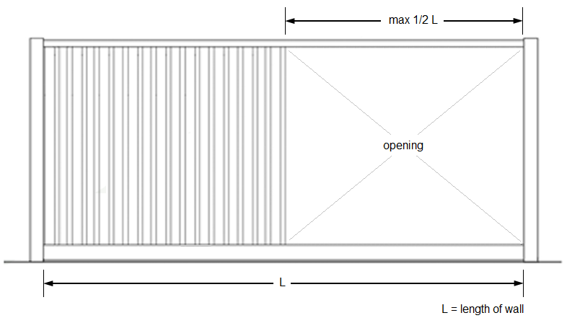
3114.8.5.3(1)
Bracing Unit Distribution--Maximum Linear Length

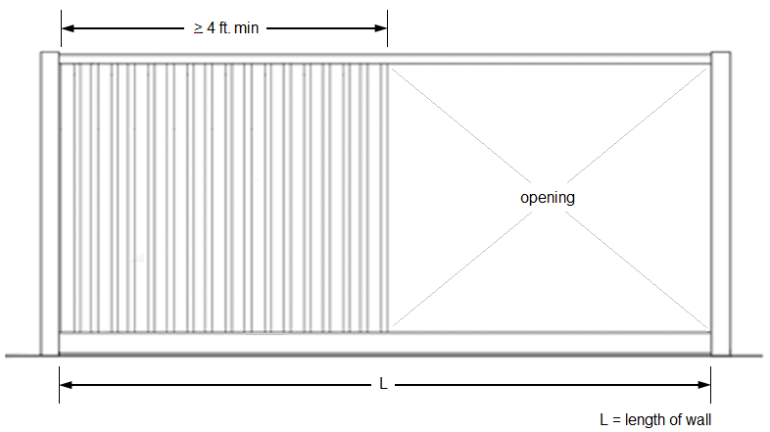
3114.8.5.3(2)
Bracing Unit Distribution -- Minimum Linear Length

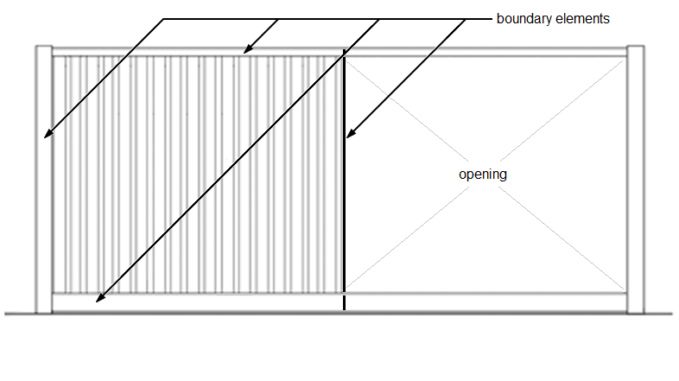
3114.8.5.3(3)
Bracing Unit Distribution -- Boundary Elements

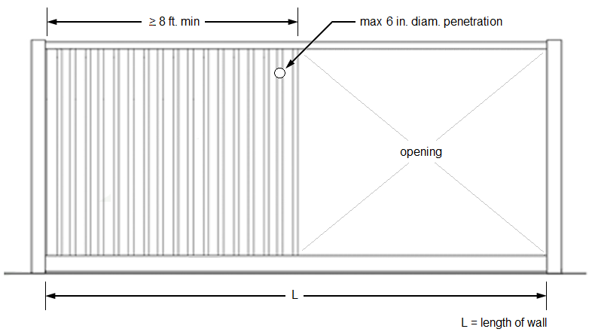
3114.8.5.3(4)
Bracing Unit Distribution -- Penetration Limitations

TABLE 3114.8.5.3
Allowable Strength Values for Intermodal Shipping Container Corrugated Steel Siding Shear Walls for Wind or Seismic Loading

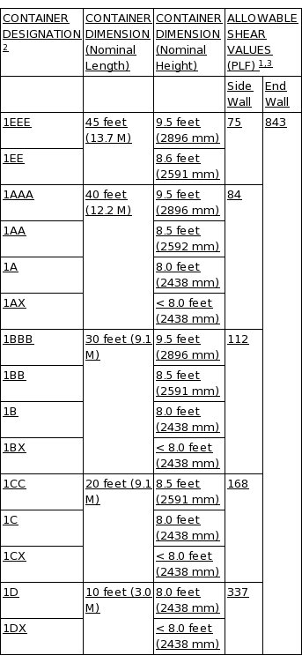

Add new standards follows:
ISO 668: 2013:
Series 1 Freight Containers - Classifications, dimensions and ratings

ISO 1496-1: 2013:
Series 1 Freight Containers - Specification and Testing - Part 1: General Cargo Containers for General Purposes

ISO 6346: 1995, with Amendment 3: 2012:
Freight Containers - Coding, Identification and marking

Appendix 4
Resources

Contact information

Containers Owner Association
www.containerownersassociation.org

ICC Evaluation Service (ICC-ES)
www.icc-es.org

ICHCA International
www.ichca.org

IICL
www.iicl.org

International Code Council (ICC)
www.iccsafe.org

International Maritime Organization (IMO)
www.imo.org

International Organization for Standards (ISO)
www.iso.org

Modular Building Institute (MBI)
www.modular.org

National Portable Storage Association (NPSA)
www.npsa.org

World Shipping Council
www.worldshipping.org

